20th April 2018

Yokohama Rubber and YOKOHAMA Magokoro (Sincere Heart) Fund Support Relief Efforts in Quake-stricken Taiwan

The Yokohama Rubber Co., Ltd., announced on 5th April 2018 that the Company and the YOKOHAMA Magokoro (Sincere Heart) Fund, established as a social contribution fund by the Company's employees, donated about 270,000 Taiwan dollars (about ¥1 million) in March through the Red Cross Society of the Republic of China to support disaster victims, a city in eastern Taiwan that was struck by a 6.4-magnitude earthquake in February.
Yokohama Rubber wishes to express their sincerest sympathies to everyone suffering from the damages caused by this earthquake, and they pray for the earliest possible full recovery and return to normal life.
The YOKOHAMA Magokoro (Sincere Heart) Fund was established in May 2016 to make donations to help fund disaster relief efforts and to provide financial support for NPOs, NGOs and other non-profit organizations working on contribution to society such as to conserve the environment and protect human rights. The Fund is supported by Yokohama Rubber employees who voluntarily contribute part of their monthly salary in units of ¥100. Yokohama Rubber matches the donations made by the Fund, thus doubling the financial support extended to people, communities and organizations in need of assistance.

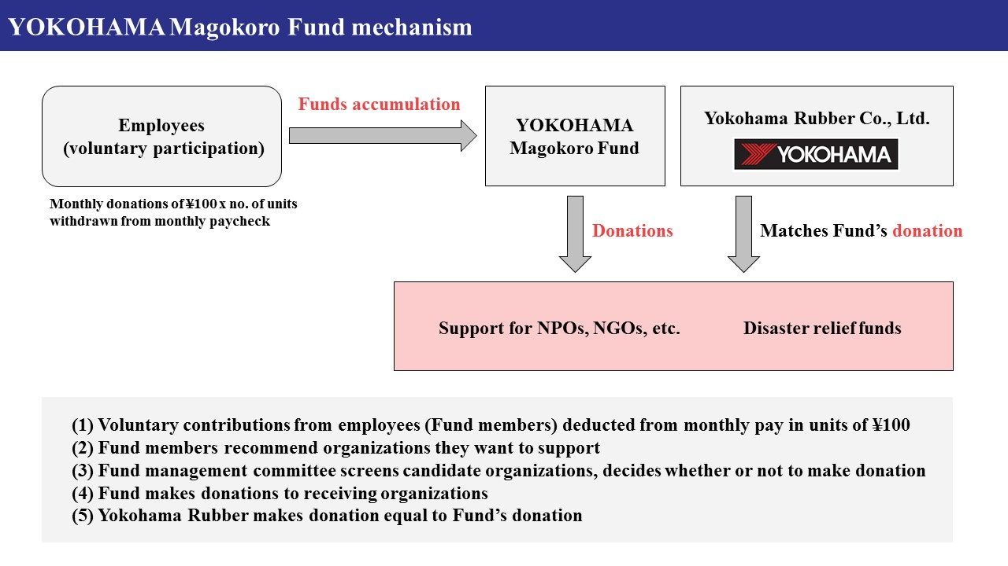
YOKOHAMA Magokoro Fund mechanism

